William Suryadharma

PPTI 12 (33)

2502040764

**Link GitHub**

Testestes

**Result Documentation**

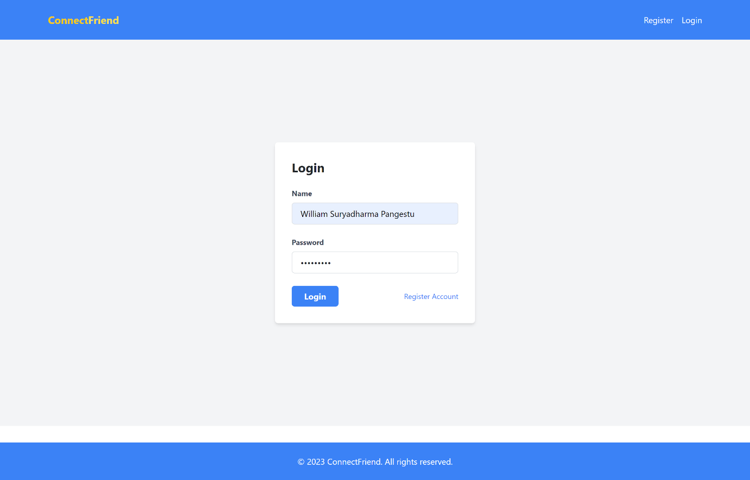

Login page

Register Page

Home Page

Add Wallet Page

Wishlist Page

Communicate Page

**Controller**

Home Controller

Register Controller

Thumb Controller

**Database Seeder**

Seeder for user

**Migrations**

User

Thumb

**Models**

User

Thumb

**Routing**

